COVER PAGE
VIT BHOPAL UNIVERSITY
VIT BHOPAL SMART VEND
A Python-Based Smart Vending Machine Management and Purchase Assistant
Submitted By: Name: SUDARSHAN CHHAPARWAL Registration No.: 26BAI10714 Branch: B.Tech Artificial Intelligence and Machine Learning
Submitted To: Faculty Name: DR. KOMARASAMY G
Course: INTRODUCTION TO PROBLEM SOLVING
Academic Year: 2026–27
INTRODUCTION
VIT Bhopal Smart Vend is a Python-based vending machine management and purchase assistant designed for the VIT Bhopal campus. The system provides information about vending machines, available products, inventory levels, prices, popular products, and unique products available across the campus.
The project allows users to search for products, find the nearest vending machine, compare product prices, and receive smart recommendations according to their available budget. Users can also add products to a cart, complete purchases, and view their previous orders.
The system also contains an administrative section for monitoring inventory, orders, revenue, and sales information. SQLite database storage is used to maintain stock and transaction-related information. The project demonstrates the practical use of Python programming, database management, data structures, functions, modular programming, and basic algorithmic problem solving.

PROBLEM STATEMENT
Students and staff on a large campus may have difficulty locating vending machines and identifying which products are available at different machines. They may also need to check product availability, prices, popular products, and suitable products according to their budget.
A traditional vending machine only provides information when a user is physically present at the machine. It does not provide a centralized way to explore multiple vending machines or analyze available products.
Therefore, the VIT Bhopal Smart Vend project aims to develop a centralized Python-based system that allows users to explore vending machines, search products, check inventory, find nearby machines, compare prices, receive budget-based recommendations, and purchase products through a simple command-line interface.
Functional Requirements
The major functional requirements of the system are:
View All Vending Machines
The system allows users to view all vending machines available on the VIT Bhopal campus along with their locations and relevant information.
View Product Catalogue
Users can view the complete catalogue of products available in the system. Products include categories such as snacks, drinks, chocolates, and other items.
View Machine Inventory
The system displays the products and their availability in individual vending machines. Inventory status can be shown as AVAILABLE, LOW, or OUT.
Search Product
Users can search for a particular product using its name or related information.
Find Nearest Machine
The system can determine the nearest vending machine based on simulated machine coordinates and display the calculated distance in kilometres.
Compare Product Prices
Users can compare the prices of a selected product across vending machines.
View Hot Sellers
The system identifies and displays popular or frequently purchased products.
View Unique Products
The system displays products that are unique or specially associated with particular vending machines.
Smart Budget Recommendation
Users can enter their available budget, and the system recommends products that can be purchased within that budget.
The recommendation feature provides both:
- Single-product options
- Product combinations
It can also display quantity, total cost, remaining budget, and available stock.
Cart and Purchase
Users can select products, add them to a cart, review their purchase, and complete the transaction.
Order History
The system stores completed orders and allows users or administrators to view previous purchase information.
Admin Panel
The administrator can access information related to:
- Low-stock products
- Orders
- Items sold
- Revenue
- Machine-wise sales
- Database inventory

Non-Functional Requirements

Usability
The system should be simple and easy to use. Menu-based navigation allows users to select different operations without requiring advanced technical knowledge.

Performance
The system should provide results quickly for common operations such as searching products, checking inventory, and generating recommendations.

Reliability
The system should correctly process purchases and maintain accurate inventory and order information.

Maintainability
The project is divided into separate modules such as main.py, data.py, and database.py, making the code easier to understand, modify, and maintain.

Data Consistency
Inventory and order information stored in the database should remain consistent after transactions.

Scalability
The system is designed so that additional vending machines, products, categories, and database features can be added in the future.
Portability
The project is developed using Python and can be executed on systems supporting Python and the required database libraries.
System Architecture
The system follows a modular architecture consisting of the following major components:
User Interface Layer
The user interacts with the application through a Python command-line menu.
Application Logic Layer
The main application handles:
- Product search
- Machine selection
- Distance calculation
- Price comparison
- Recommendations
- Cart operations
- Purchase processing
- Admin operations
Data Layer
Static information such as vending machines, products, and initial inventory is maintained in the data.py module.
Database Layer
The database.py module manages SQLite database operations such as:
- Creating tables
- Loading stock
- Updating stock
- Saving orders
- Retrieving order information
- Calculating revenue
- Generating sales statistics
Architecture Flow

+----------------------+
| USER |
+----------+-----------+
|
v
+----------------------+
| main.py |
| User Interface |
+----------+-----------+
|
v
+----------------------+
| Application Logic |
| Search / Cart / |
| Recommendation / |
| Purchase / Admin |
+----------+-----------+
|
+-------------+-------------+
| |
v v
+---------------+ +---------------+
| data.py | | database.py |
| Products | | SQLite DB |
| Machines | | Orders |
| Inventory | | Stock |
+---------------+ | Sales |
+---------------+

Design Diagrams
Use Case Diagram
Actors
- User
- Administrator
User Use Cases
- View vending machines
- View products
- Check inventory
- Search product
- Find nearest machine
- Compare prices
- View hot sellers
- View unique products
- Get budget recommendations
- Add products to cart
- Purchase products
- View order history
Administrator Use Cases
- View low-stock products
- View orders
- View revenue
- View total items sold
- View machine-wise sales
- Monitor inventory
Use Case Representation

+----------------------+
| VIT SMART VEND |
+----------------------+

USER --------------------------------------------

|----> View Vending Machines
|----> View Product Catalogue
|----> View Inventory
|----> Search Product
|----> Find Nearest Machine
|----> Compare Prices
|----> View Hot Sellers
|----> View Unique Products
|----> Smart Budget Recommendation
|----> Cart & Purchase
|----> Order History

ADMIN ------------------------------------------

|----> View Low Stock
|----> View Orders
|----> View Revenue
|----> View Items Sold
|----> View Machine-wise Sales
|----> Monitor Inventory
Workflow Diagram
The overall workflow of the system is:

START
|
v
Initialize System
|
v
Load Database/Data
|
v
Display Menu
|
v
User Selects Option
|
+-------+--------+
| |
v v
Information Purchase
Operations Operations
| |
| v
| Select Product
| |
| v
| Add to Cart
| |
| v
| Check Stock
| |
| +-----+-----+
| | |
| YES NO
| | |
| v v
| Purchase Show Error
| |
| v
| Update Stock
| |
| v
| Save Order
| |
+----------+
|
v
Return to Main Menu
|
v
EXIT
Sequence Diagram
The following sequence represents a product purchase:
User main.py Database Inventory
| | | |
| Select | | |
| Product ------>| | |
| | Check Stock | |
| |------------->| |
| | |-------------->|
| | | Stock Result |
| |<-------------|<--------------|
| | | |
| Confirm ------>| | |
| | Update Stock | |
| |------------->| |
| | |-------------->|
| | | Update Stock |
| | |<--------------|
| | Save Order | |
| |------------->| |
| | Order Saved | |
| |<-------------| |
| Purchase | | |
| Confirmation <| | |
Class / Component Diagram
Although the project is primarily function-based Python, its major logical components can be represented as follows:
+-----------------------+
| Main System |
| main.py |
+-----------+-----------+
|
+------+------+
| |
v v
+----------+ +-------------+
| Data | | Database |
| Module | | Module |
| data.py | | database.py |
+----------+ +-------------+
| |
| v
| +-----------+
| | SQLite |
| | Database |
| +-----------+
|
+-------------------+
| |
v v
Vending Machines Products
|
v
Inventory

ER Diagram
The system uses database storage for stock and transaction information.
A simplified ER representation is:
+----------------------+
| MACHINE |
+----------------------+
| machine_id (PK) |
| machine_name |
| location |
| coordinate_x |
| coordinate_y |
+----------+-----------+
|
| contains
|
v
+----------------------+
| INVENTORY |
+----------------------+
| inventory_id (PK) |
| machine_id (FK) |
| product_id (FK) |
| quantity |
+----------+-----------+
|
|
v
+----------------------+
| PRODUCT |
+----------------------+
| product_id (PK) |
| product_name |
| category |
| price |
+----------------------+

+----------------------+
| ORDERS |
+----------------------+
| order_id (PK) |
| customer/order info |
| total_amount |
| order_date |
+----------+-----------+
|
| contains
v
+----------------------+
| ORDER_ITEMS |
+----------------------+
| item_id (PK) |
| order_id (FK) |
| product_id (FK) |
| quantity |
| price |
+----------------------+
Design Decisions & Rationale
Choice of Python
Python was selected because it is beginner-friendly, has simple syntax, and provides strong support for data structures, database connectivity, and application development.
Choice of SQLite
SQLite was selected because it is lightweight, easy to configure, and does not require a separate database server. It is suitable for a Python academic project involving inventory and order storage.
Modular Programming
The project separates data and database operations from the main application logic. This improves code organization and makes future modifications easier.
Menu-Based Interface
A command-line interface was selected because the primary objective of the project is to demonstrate functional Python programming and system logic without requiring a web interface.
Simulated Coordinates
Vending-machine locations are represented using coordinates. These coordinates allow the system to calculate relative distances and identify the nearest machine.
Budget Recommendation
A budget recommendation system was implemented to make the project more useful than a basic vending-machine catalogue. It allows users to determine what they can purchase with a specified amount of money.
Implementation Details
The project is implemented using Python and SQLite.
Main Python File
The main.py file controls the primary application flow and contains the main menu and major user functions.
The application provides options for:
1. View All Vending Machines
2. View Product Catalogue
3. View Machine Inventory
4. Search Product
5. Find Nearest Machine
6. Compare Product Prices
7. View Hot Sellers
8. View Unique Products
9. Smart Budget Recommendation
10. Cart & Purchase
11. Order History
12. Admin Panel
13. Exit
Data Module
The data.py module contains information about:
- Vending machines
- Products
- Product categories
- Product prices
- Initial inventory
The system contains different products across different machines instead of displaying exactly the same products everywhere.
Database Module
The database.py module handles database-related operations.
Important operations include:
- Creating database tables
- Inserting initial stock
- Loading stock
- Updating stock
- Saving orders
- Retrieving orders
- Retrieving order items
- Checking database stock
- Finding low-stock products
- Calculating total revenue
- Calculating total orders
- Calculating total items sold
- Calculating machine-wise sales
Inventory Management
Inventory is tracked for individual machines. The system can identify whether a product is:
AVAILABLE
LOW
OUT OF STOCK
When a purchase is completed, the corresponding stock quantity is updated.
Search Function
The search function allows users to enter a product name and retrieve matching products from the product catalogue.
Nearest Machine Calculation
The project uses simulated coordinates for vending machines. Distance is calculated using coordinate differences.
The calculated distance is converted into kilometres and displayed to the user.
Smart Budget Recommendation
The budget recommendation system accepts the user's budget and identifies products that can be purchased within the available amount.
For example, if the user enters:
Budget = ₹120
the system can display:
SINGLE PRODUCT OPTIONS
Product: Example Product
Price: ₹40
Quantity Possible: 3
Total Cost: ₹120
Remaining Budget: ₹0
It can also generate combinations of different products that remain within the specified budget.
Cart and Purchase
The cart feature allows users to select multiple products before completing the purchase.
The system checks stock availability, calculates the total amount, updates inventory, and stores the transaction in the database.
Admin Panel
The administrator can view important business information such as:
- Low-stock items
- Number of orders
- Items sold
- Revenue
- Machine-wise sales
This provides basic analytical capabilities for vending-machine management.
Screenshots / Results
The following screenshots should be added to the final report from the actual running project.
Screenshot 1 – Main Menu
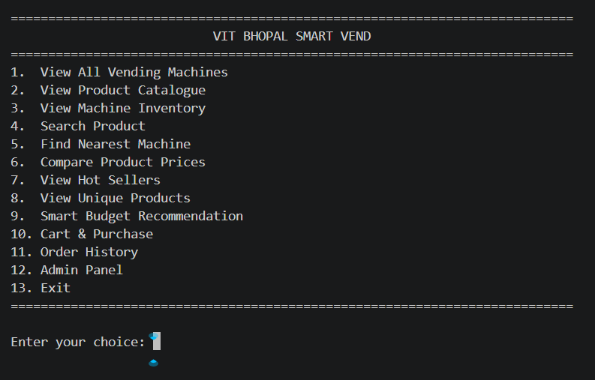
Description: Shows the main menu of the VIT Bhopal Smart Vend application with all available operations.
Screenshot 2 – Vending Machine List
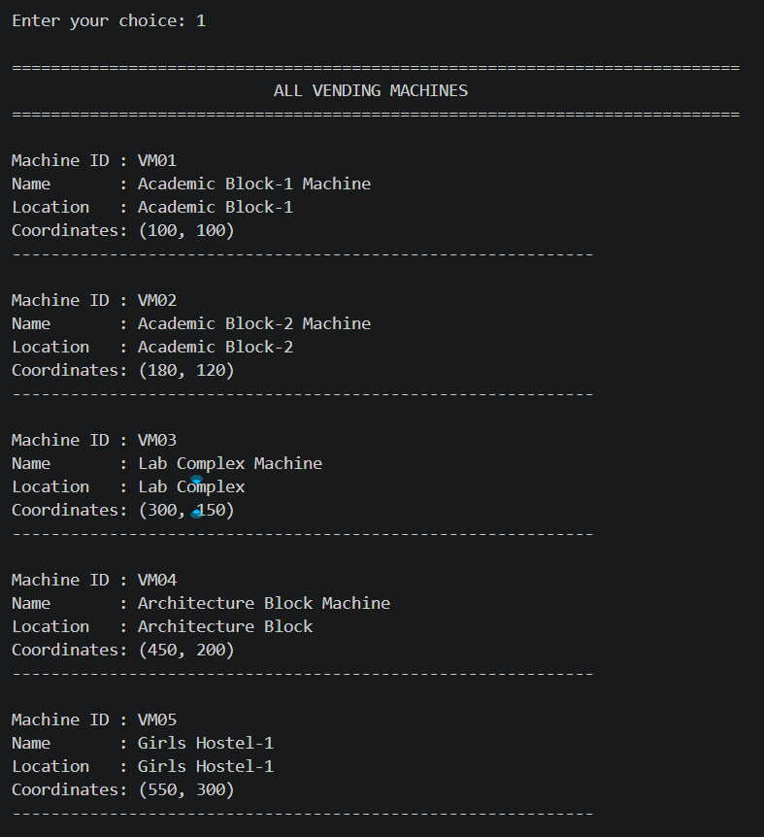
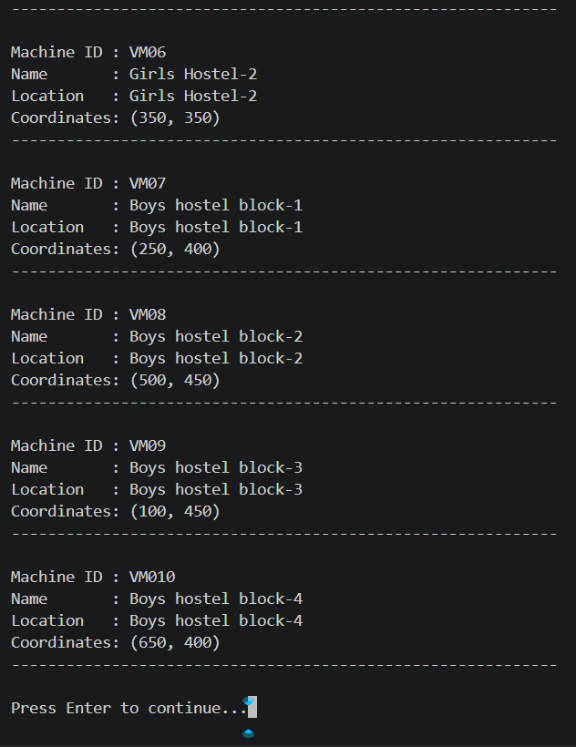
Description: Displays the vending machines available on the VIT Bhopal campus.
Screenshot 3 – Product Catalogue
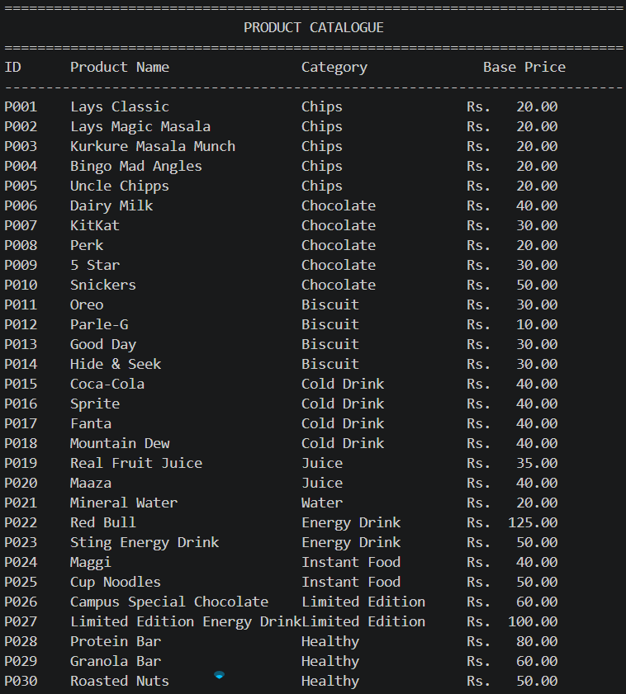
Description: Displays available products along with their categories and prices.
Screenshot 4 – Machine Inventory
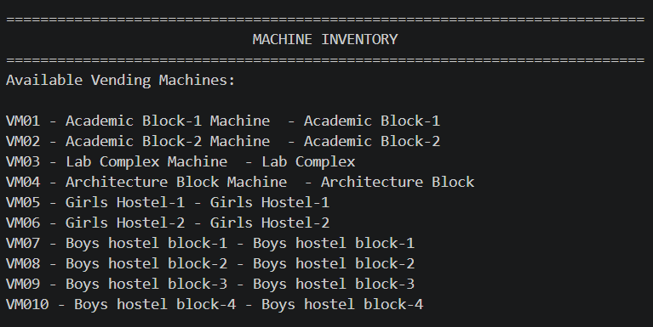
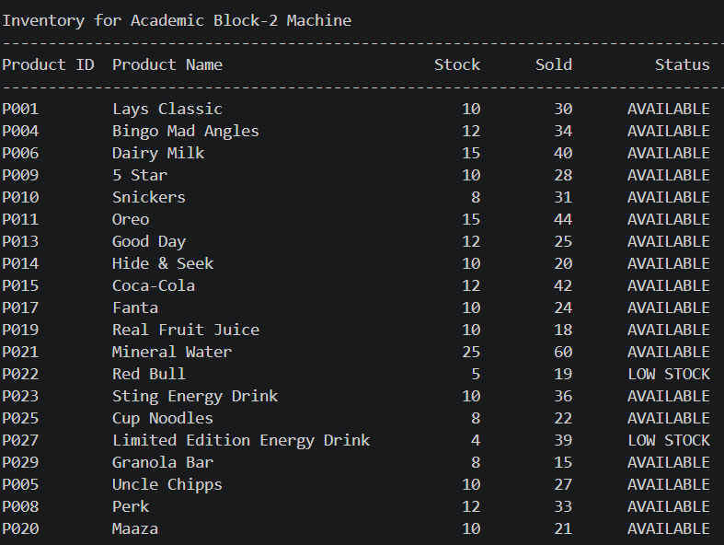
Description: Displays product availability and inventory status for a selected vending machine.
Screenshot 5 – Product Search
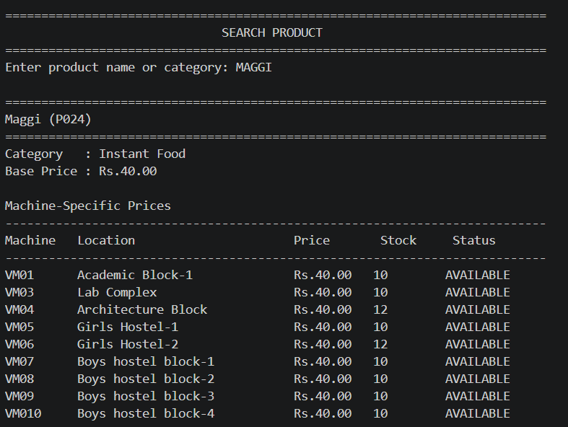
Description: Demonstrates searching for a particular product.
Screenshot 6 – Nearest Machine
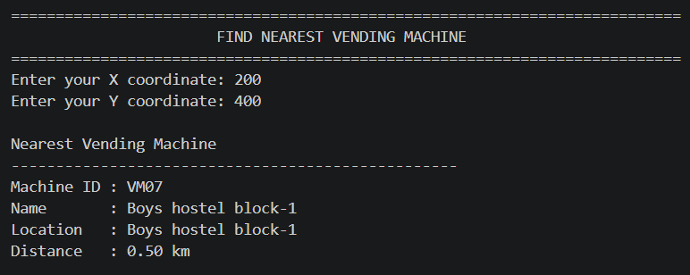
Description: Displays the nearest vending machine and its distance in kilometres.
Screenshot 7 – Price Comparison
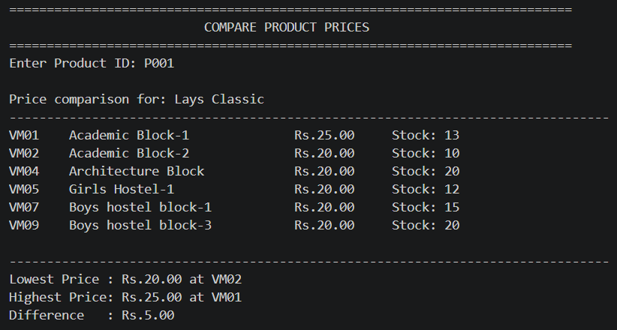
Description: Displays product price information across available vending machines.
Screenshot 8 – Hot Sellers
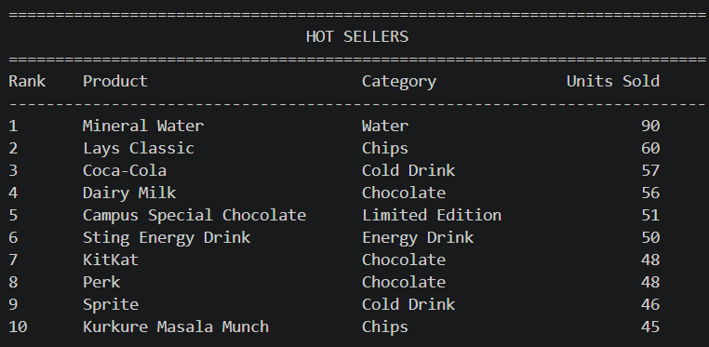
Description: Displays products identified as popular or high-selling products.
Screenshot 9 – Unique Products
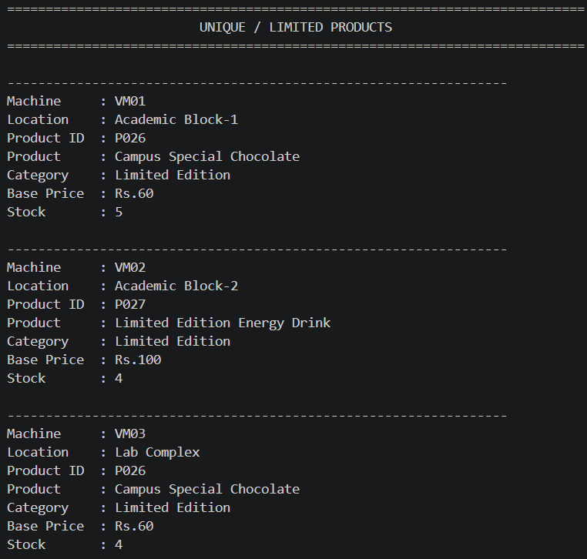

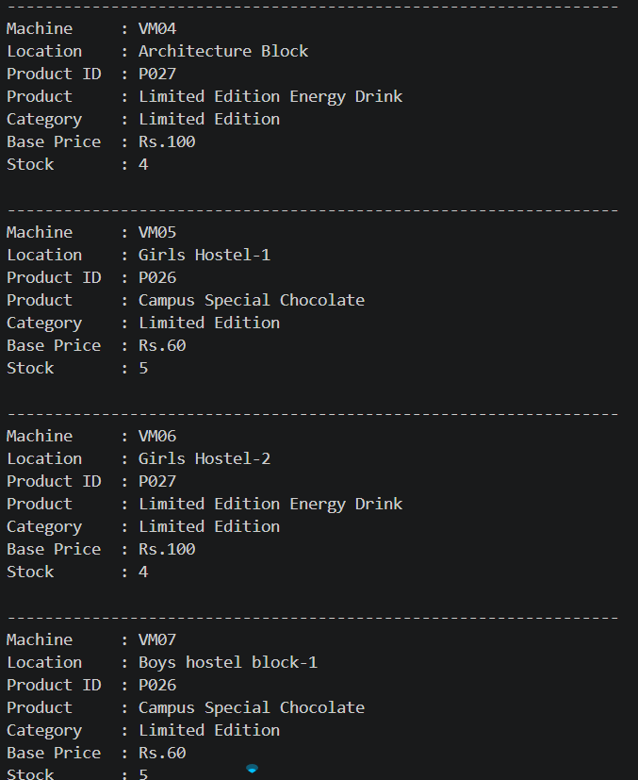
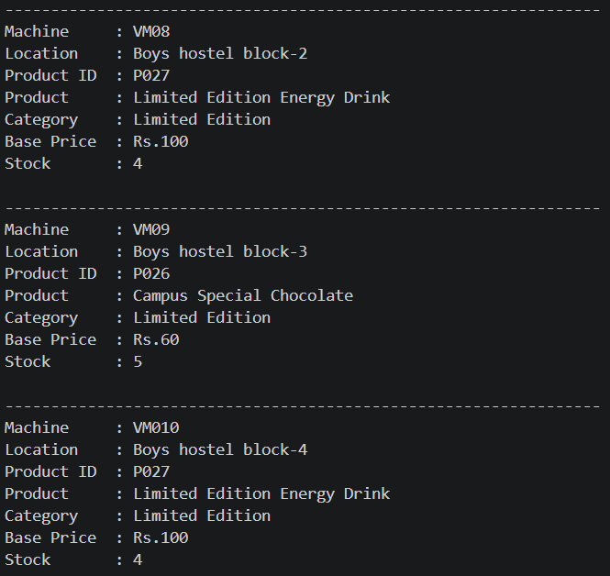
Description: Displays products that are unique or limited to particular vending machines.
Screenshot 10 – Smart Budget Recommendation
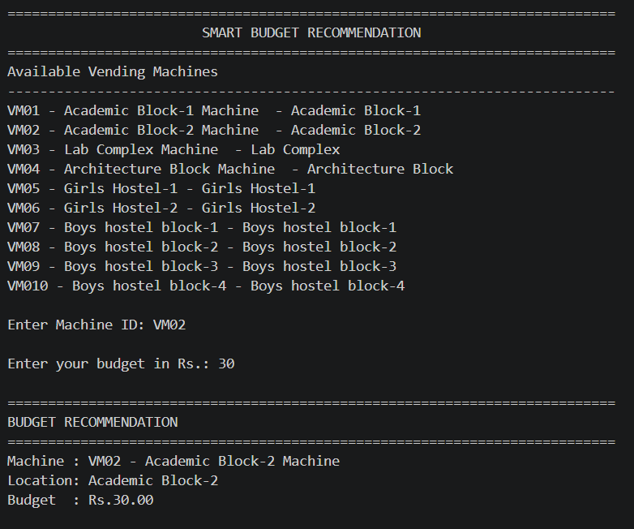
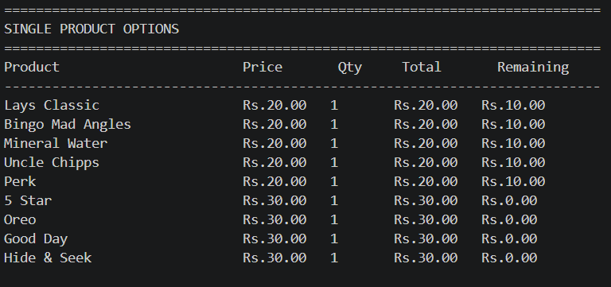
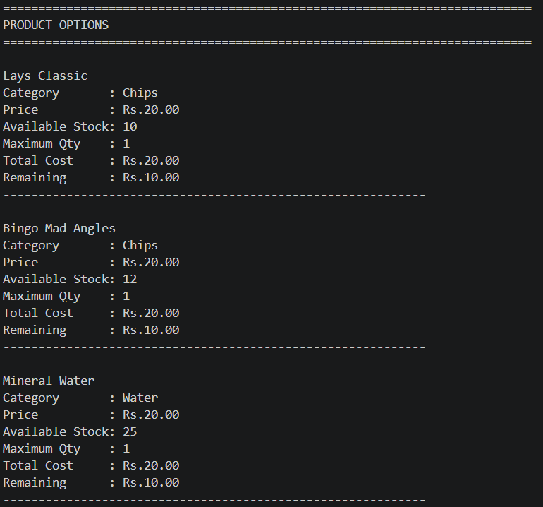
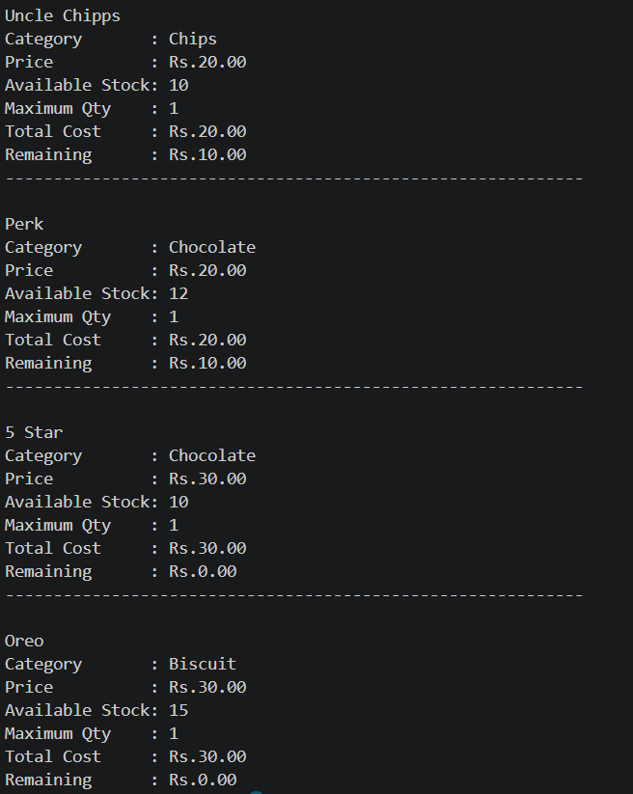
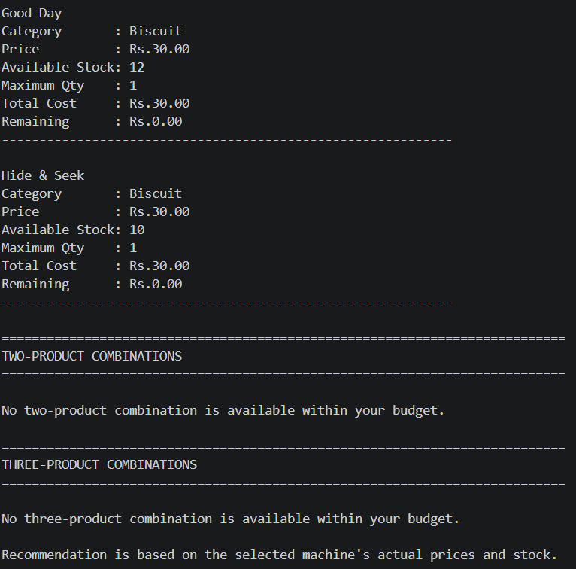
Description: Demonstrates product recommendations based on a user's budget, including individual products and combinations.
Screenshot 11 – Cart and Purchase
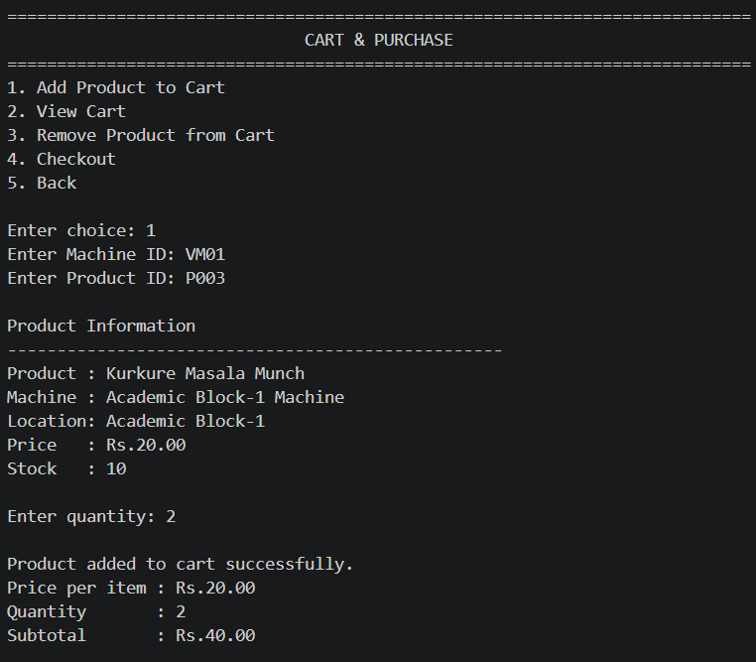
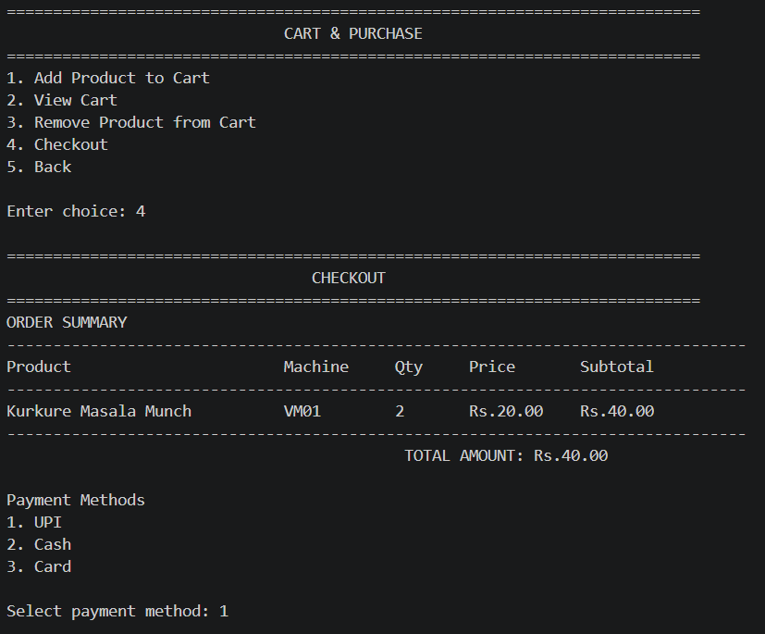
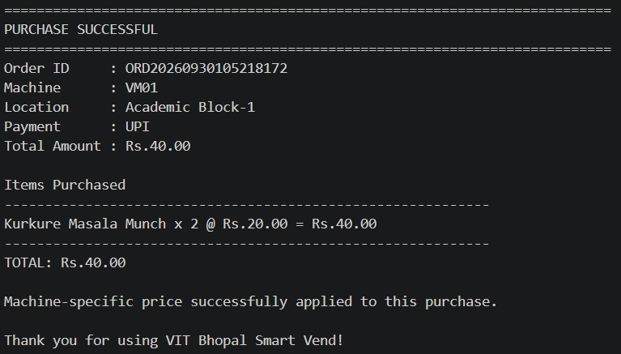
Description: Shows selected products, quantities, total cost, and purchase confirmation.

Screenshot 12 – Order History
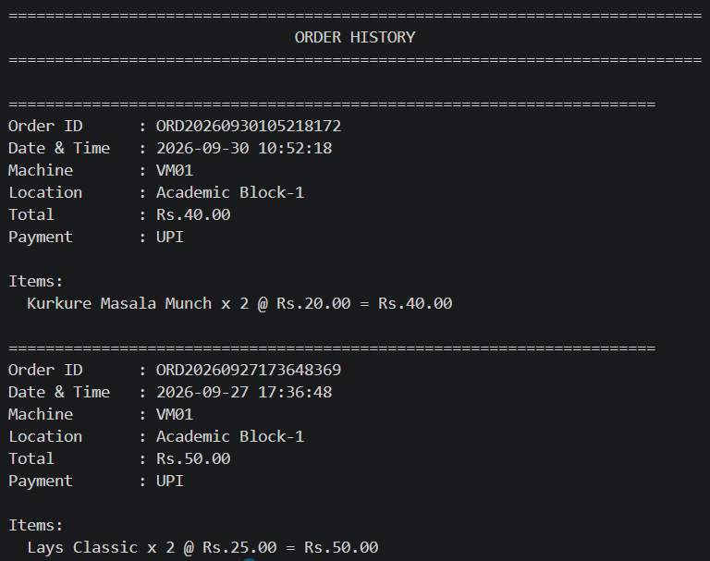
Description: Displays previously completed orders.
Screenshot 13 – Admin Panel
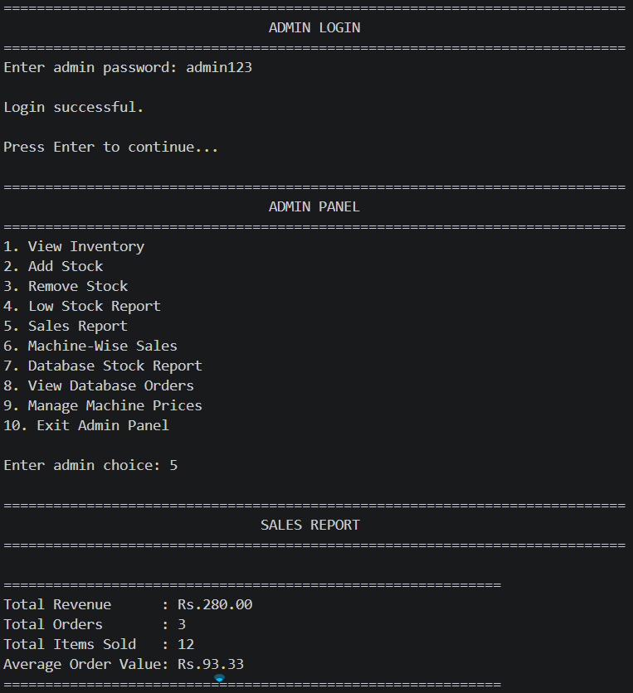
Description: Displays administrative information such as revenue, orders, low-stock items, and sales statistics.

